**User Guide**

**Controls:**

- Walk Forward

- Walk Backwards

- Walk Left

- Walk Right

- Operate Switch

- Shoot

Mouse Movement - Aim/Look

- Settings Menu

**Tutorial:**



Select your maze generation algorithm before you start the game. Try each one, as they all produce different style mazes and provide you with different challenges.

Recursive Backtracker- This algorithm has long pathways with fewer dead-ends.

Prim’s Algorithm – By far the hardest mazes to solve, only the best players can escape! It produces many short pathways with lots of dead ends.

Recursive Division – Produces many long straight corridors and includes loops to help avoid the enemies. The enemies will find you very quickly though.

Genetic Algorithm – Produces a range of different types of mazes with no common theme. Also, includes cycles and the enemies find you quickly. The easiest maze algorithm to pass through.

**Level 1:**

Upon entering the maze, you must find the coloured numbers to solve the puzzle:

There is a yellow, a blue and a red number hidden somewhere inside the maze. You need to find all of them to escape.

However, you are not alone. You are unarmed so you cannot engage with these enemies. You must try to avoid them and move through the maze quickly. Any damage you take inside the maze will affect your health in the next level.

Find the Exit:

Enter the code into the text box matching the numbers to the colours above it:

Your score will be inversely proportional to your time, displayed in the top left of the HUD:

**Level 2:**

Now you have escaped the maze, you found a weapon. It’s time to fight back!

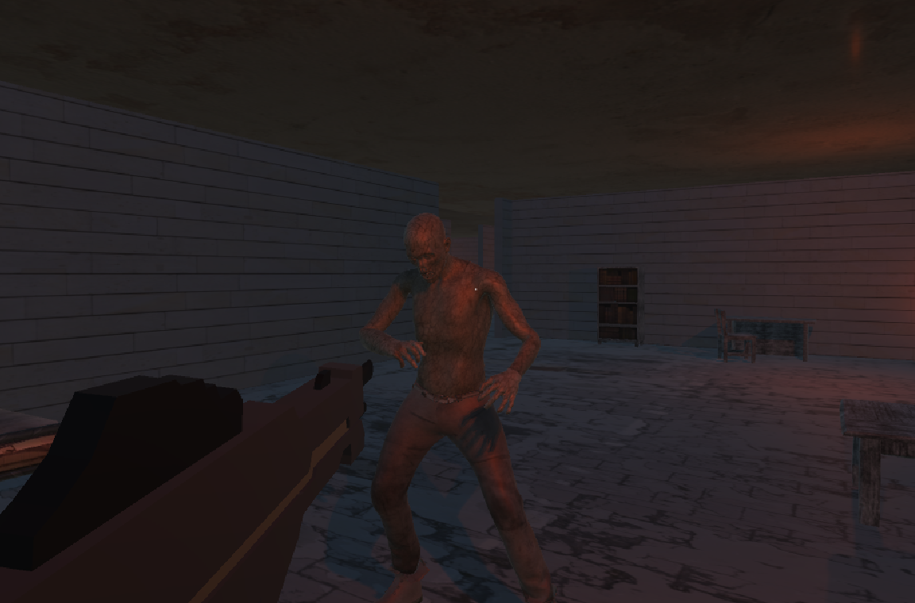

Explore the dungeon and run from and fight the zombies!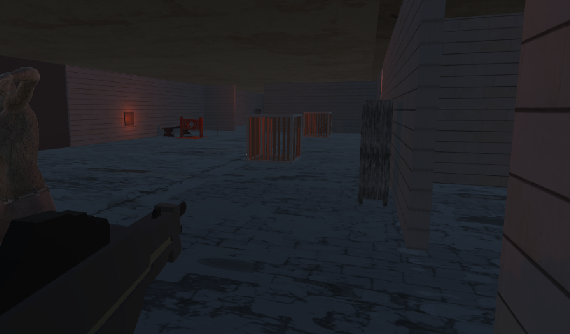

Operate the switches to open/close doors. Beware, as closing one door will most likely open another.

Switch:

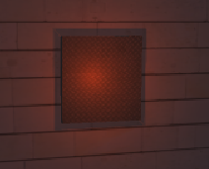

Door:

Watch out for the zombies emerging from the darkness.

Keep an eye on your health bar and health points (HP). You can also track your current score in the top left corner of the HUD.

Find pickups from killed enemies to help you survive.

Ammunition:

Damage increase:

Health increase:

The intensity of the zombies will increase quite quickly. So, be ready and see how long you can survive. Your score will increase by one with each kill.

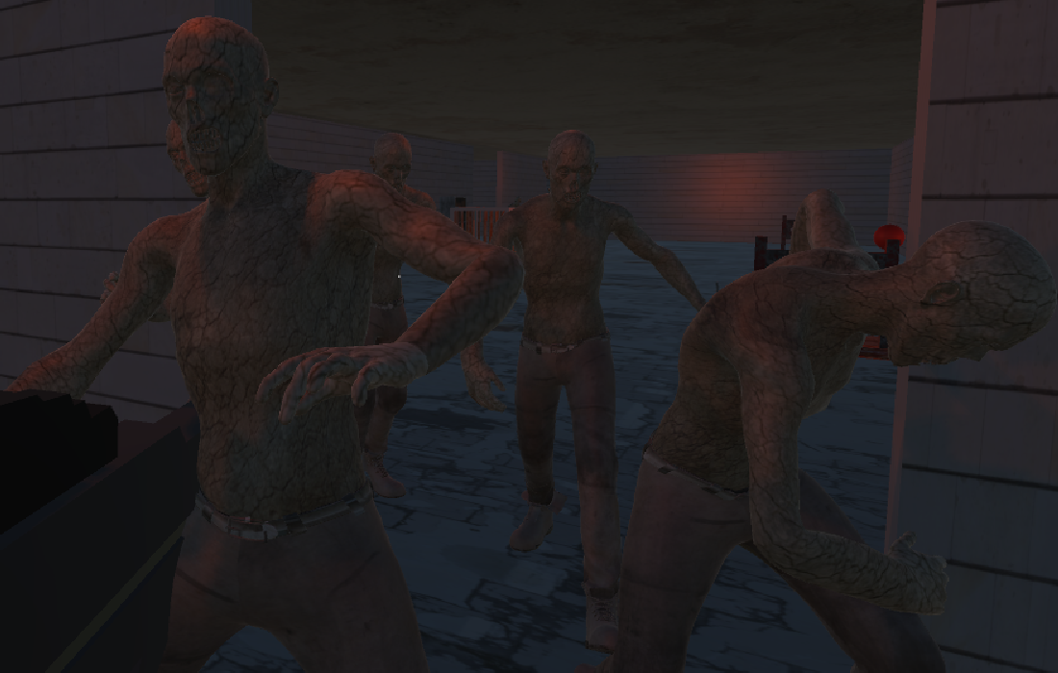

Save you final score to the global leaderboard and see how you fare against other players around the world:

Adjust sound settings and mouse sensitivity in-game in the settings menu.

